Appendix A of the ‘Soil Organisms’ Article:

Abrupt boundaries between mountain meadows and forests separate ground-dwelling invertebrate communities: a case study from South Tyrol, Italy

Helene Blasbichler¹, Julia Plunger¹, Julia Seeber^{1,2}, Michael Steinwandter^{1,}*
1 Institute for Alpine Environment, Eurac Research, Viale Druso 1, 39100 Bozen/Bolzano, Italy
2 Universität Innsbruck, Department of Ecology, Technikerstrasse 25, 6020 Innsbruck, Austria
* Corresponding author: michael.steinwandter@eurac.edu

Type of submission: Article
DOI: 10.25674/so95iss3id338

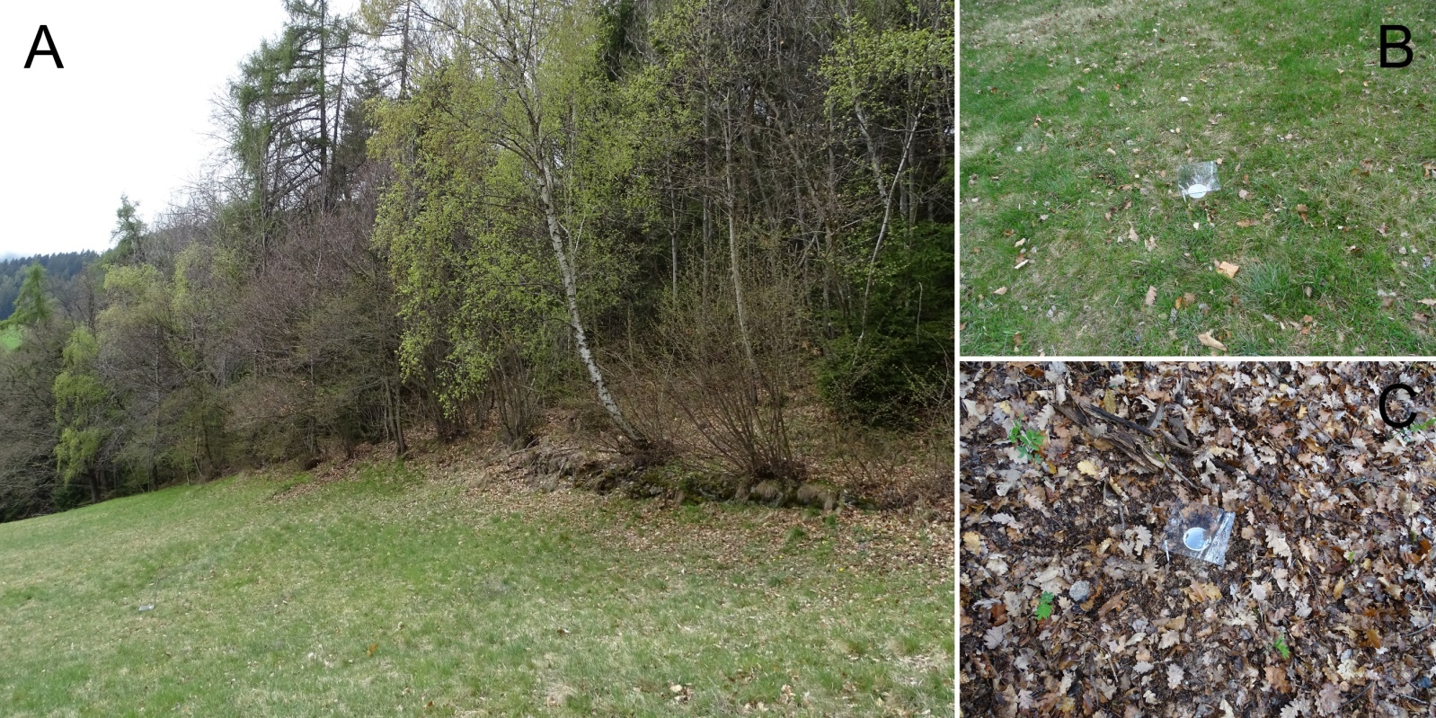
Figure A1. Photos of the study area of Barbian/Barbiano, South Tyrol (Italy) with an extensively managed meadow and the abrupt shift to the mixed forest. (A) Overview of the plot EH1. (B) A pitfall trap installed in the extensively managed meadow plot (‘MM’). (C) A pitfall trap installed in the mixed forest plot (‘FF’). (Photo credits: Michael Steinwandter).

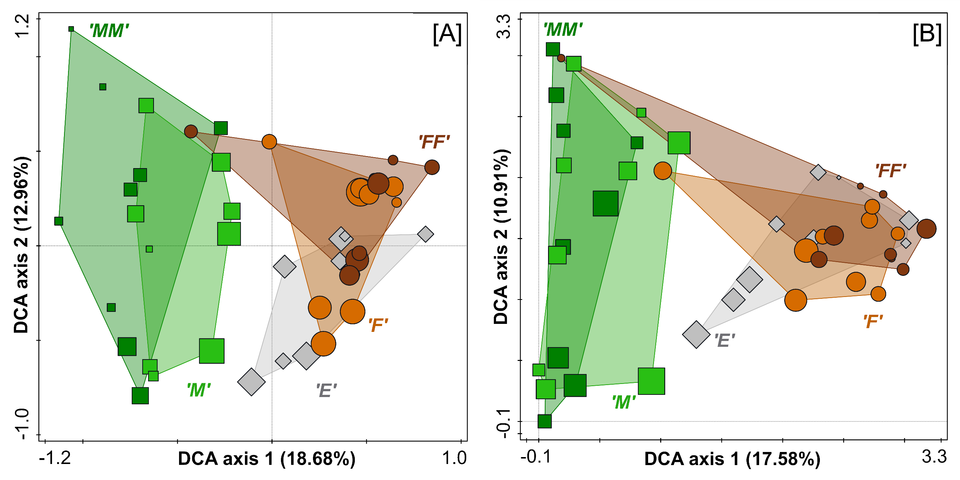
Figure A2. Unconstrained Detrended Canonical Analyses (DCA) of log-transformed ground-dwelling macro-invertebrate abundances from montane meadows and mixed forests in South Tyrol, Italy. Each data point represents a pitfall trap along a linear transect starting from extensive meadows (‘MM’, ‘M’, squares) across an abrupt ecotone (‘E’, diamonds) towards mixed forest stands (‘F’, ‘FF’, circles). The point size depicts the number of taxa. (A) Total fauna at family level. (B) Araneae at species level.

Figure A3. Overview of indicator taxa ground-dwelling macro-invertebrate abundances from montane meadows and mixed forests in South Tyrol, Italy. The data is on family level and comes from pitfall traps along a linear transect from extensively meadows (‘MM’, ‘M’, squares) across an abrupt ecotone (‘E’, diamonds) towards mixed forest stands (‘F’, ‘FF’, circles). The colour code indicates the IndVal values (see colour bar), the squared ellipses a significance at p < 0.05.
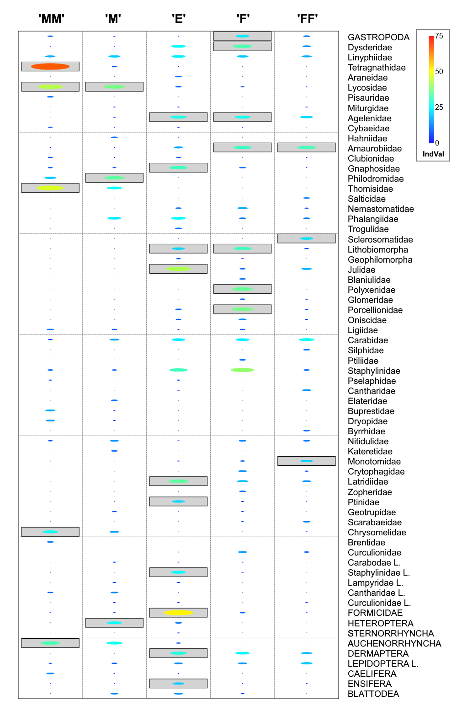

Figure A4. Abundance-based accumulation curves for ground-dwelling macro-invertebrates from montane meadows and mixed forests in South Tyrol, Italy. The data is on family level and comes from pitfall traps along a linear transect from extensively meadows (‘MM’, ‘M’, squares) across an abrupt ecotone (‘E’, diamonds) towards mixed forest stands (‘F’, ‘FF’, circles). The curves show from left to right: the sampling coverage, taxa and species richness (Hill number q=0), Shannon (q=1) and Simpson diversity (q=2). This figure (C) is a supplement to Figure 4 from the main text.

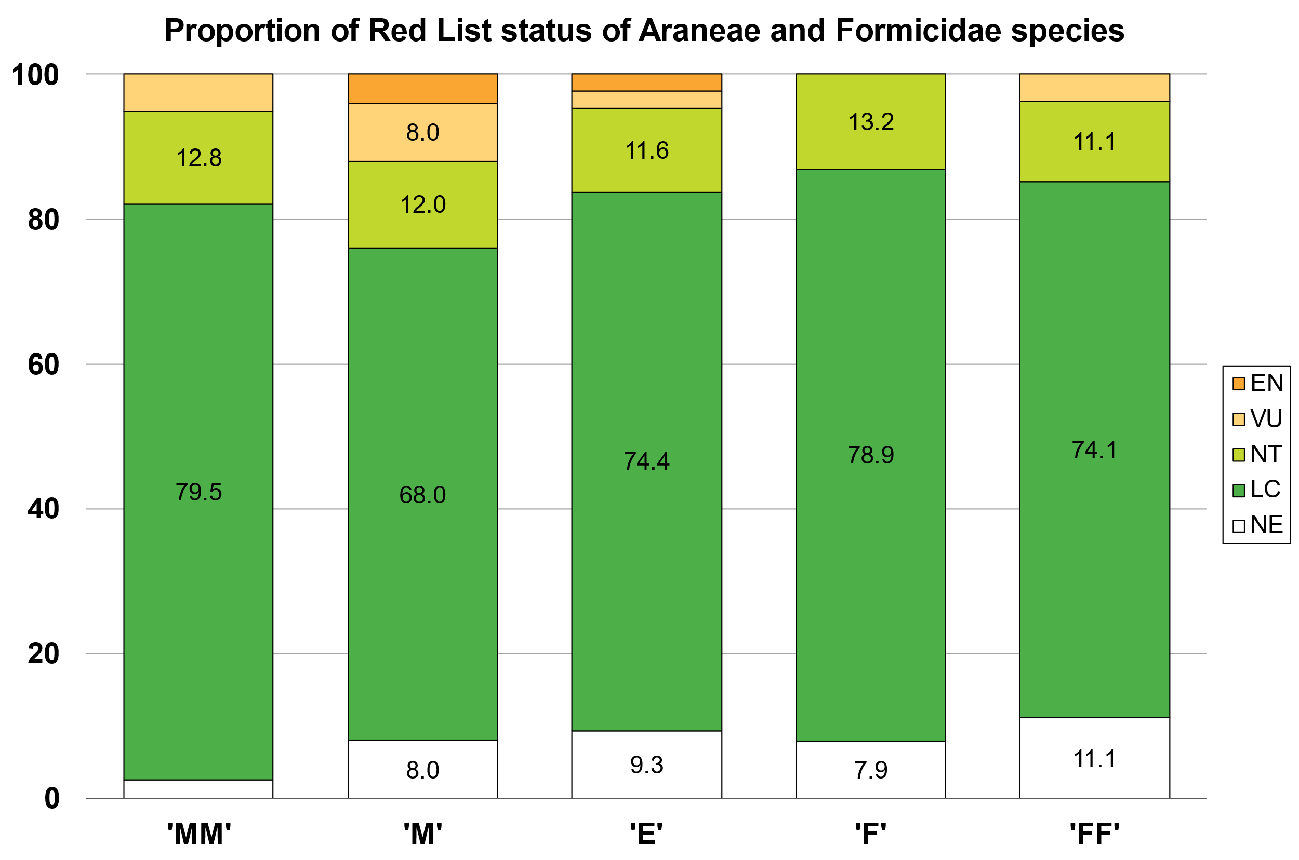
Figure A5. Proportion of Red List status of Araneae and Formicidae species from montane meadows and mixed forests in South Tyrol, Italy. The colour codes correspond to the official IUCN Red List categories. The Red List of South Tyrol was used for Araneae (Gapp 1994) and the Red List of Germany for Formicidae (Seifert 2018). NE, not evaluated; LC, least concern; NT, near threatened; VU, vulnerable; EN, endangered.

Table A1. Results of a PERMANOVAs (permutational multivariate analysis of variance) with post-hoc tests of ground-dwelling macro-invertebrate abundances from montane meadows and mixed forests in South Tyrol, Italy. Data comes from pitfall traps along a linear transect starting from extensive meadows (‘MM’, ‘M’) across an abrupt ecotone (‘E’) towards mixed forest stands (‘F’, ‘FF’). p-levels: * < 0.05, ** < 0.01, *** < 0.001, ns = not significant.
Comparisons | F-value | p-value | Significance levels
‘MM’ ↔ ‘M’ | 1.7773 | 0.110 | n.s.
‘MM’ ↔ ‘E’ | 6.3300 | 0.001 | ***
‘MM’ ↔ ‘F’ | 6.0239 | 0.001 | ***
‘MM’ ↔ ‘FF’ | 8.5645 | 0.001 | ***
‘M’ ↔ ‘E’ | 4.6762 | 0.001 | ***
‘M’ ↔ ‘F’ | 4.1079 | 0.002 | **
‘M’ ↔ ‘FF’ | 5.9418 | 0.001 | ***
‘E’ ↔ ‘F’ | 1.8943 | 0.117 | n.s.
‘E’ ↔ ‘FF’ | 3.0242 | 0.012 | *
‘F’ ↔ ‘FF’ | 0.6139 | 0.933 | n.s.

Table A2. Mean biodiversity indices and standard deviation (in parentheses) of ground-dwelling macro-invertebrates from montane meadows and mixed forests in South Tyrol, Italy. The data come from pitfall traps along linear transects starting from extensively managed meadows (‘MM’, ‘M’) across sharp and abrupt ecotones (‘E’) towards mixed forest stands (‘F’, ‘FF’). Biodiversity indices were calculated: (A) Including all taxa at the highest available resolution. (B) At family level. (C) For Araneae. (D) Formicidae at species level. The number of taxa is given in parenthesis in the titles. Results of ANOVAs and Tukey’s HSD tests are given for significant differences. n = 9; p-levels: * < 0.05, ** < 0.01, *** < 0.001.
(A) All taxa (157) | ‘MM’ |  | ‘M’ |  | ‘E’ |  | ‘F’ |  | ‘FF’ |  | p
Taxa richness | 21.00 | (4.74)ª | 24.44 | (4.59)ª | 27.67 | (7.75)ª | 26.44 | (4.45)ª | 20.44 | (4.45)ª | *
Shannon diversity | 2.205 | (0.638) | 2.735 | (0.351) | 2.292 | (0.586) | 2.785 | (0.508) | 2.662 | (0.362)
Simpson diversity | 0.760 | (0.182) | 0.893 | (0.044) | 0.759 | (0.183) | 0.881 | (0.100) | 0.883 | (0.071)
Unique taxa | 9 |  | 16 |  | 10 |  | 7 |  | 4
(B) Family level (66)
Taxa richness | 13.89 | (2.76)ª | 16.78 | (3.46)^{ab} | 19.44 | (3.54)^{b} | 19.33 | (3.32)^{b} | 16.33 | (3.00)^{ab} | **
Shannon diversity | 1.756 | (0.465)ª | 2.271 | (0.455)^{ab} | 2.066 | (0.527)^{ab} | 2.475 | (0.436)^{b} | 2.415 | (0.275)^{b} | **
Simpson diversity | 0.695 | (0.152)ª | 0.828 | (0.099)^{ab} | 0.749 | (0.178)^{ab} | 0.860 | (0.097)^{ab} | 0.865 | (0.065)^{b} | *
Unique species | 2 |  | 3 |  | 2 |  | 3 |  | 4
(C) Araneae (89)
Species richness | 12.33 | (3.46) | 12.56 | (3.61) | 13.33 | (5.12) | 12.67 | (2.44) | 9.00 | (3.57)
Shannon diversity | 1.682 | (0.561)ª | 2.073 | (0.395)^{ab} | 2.314 | (0.665)^{ab} | 2.464 | (0.281)^{b} | 2.011 | (0.419)^{ab} | *
Simpson diversity | 0.666 | (0.201)ª | 0.801 | (0.086)^{ab} | 0.828 | (0.180)^{ab} | 0.890 | (0.049)^{b} | 0.823 | (0.079)^{ab} | *
Unique species | 6 |  | 9 |  | 8 |  | 4 |  | 1
(D) Formicidae (19)
Species richness | 1.44 | (1.24)^{ab} | 1.89 | (1.17)ª | 1.33 | (1.00)^{ab} | 0.56 | (0.73)^{b} | 0.44 | (0.53)^{b} | *
Shannon diversity | 0.712 | (0.435)ª | 0.727 | (0.493)ª | 0.236 | (0.473)ª | 0.008 | (0.017)ª | NA |  | *
Simpson diversity | 0.687 | (0.340)ª | 0.565 | (0.391)^{ab} | 0.141 | (0.308)^{bc} | 0.002 | (0.005)^{c} | NA |  | **
Unique species | 3 |  | 5 |  | 1 |  | 1 |  | 0

